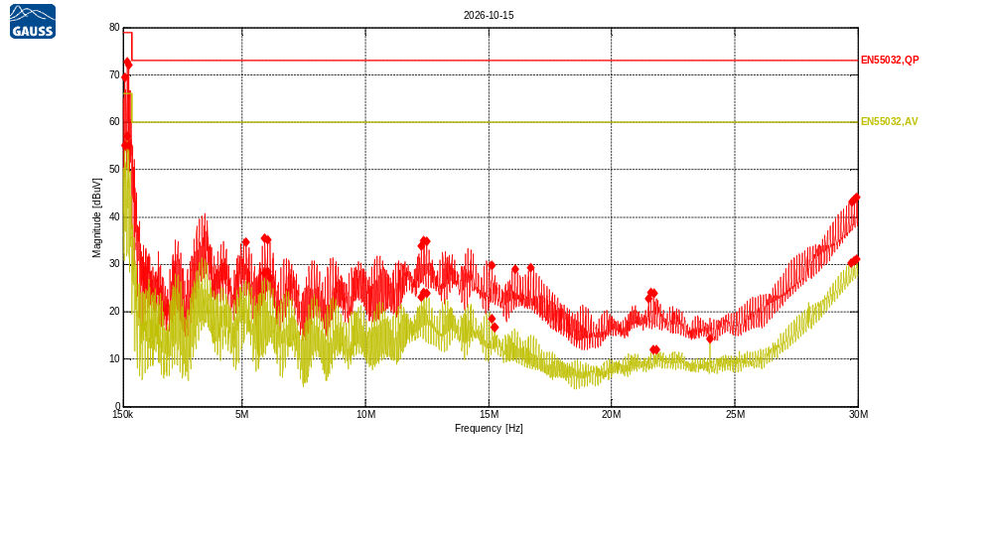
Receiver Model:
Protocol Number:
Serial Number:
Operation State:
Notes:
123123

Traces:
Trace | Start | Step | Stop | IF Bandwidth | Detector | Dwell time | Attenuation | Transducer | LISN | Notes
Scan2 | 150.0 kHz | 5.0 kHz | 30.0 MHz | 9kHz | QP | 200.0 ms | Auto | TDF1 | -
Scan1 | 150.0 kHz | 5.0 kHz | 30.0 MHz | 9kHz | Average | 200.0 ms | Auto | TDF1 | -

Transducers:
TDF1: LISN Compower AC Neutral

Limit lines:
EN55032,QP: EN55032 Cond,Class A,QP, 150kHz-30MHz
EN55032,AV: EN55032 Cond,Class A,Average, 150kHz-30MHz
Scan2: 150.0 kHz, 5.0 kHz, 30.0 MHz; IF:9kHz, 200.0 ms QP, Att AutodB
f | Mag [dBuV] | Limit | Diff | Trans | Name | Comment
218.66125 kHz | 69.51 | 79.00 | 9.49 | 0.16 | EN55032,QP
323.941834 kHz | 72.75 | 79.00 | 6.25 | 0.04 | EN55032,QP
378.870834 kHz | 72.10 | 79.00 | 6.90 | 0.02 | EN55032,QP
5.15769385 MHz | 34.74 | 73.00 | 38.26 | 0.09 | EN55032,QP
5.91754502 MHz | 35.52 | 73.00 | 37.48 | 0.09 | EN55032,QP
6.02740302 MHz | 35.12 | 73.00 | 37.88 | 0.09 | EN55032,QP
12.2709994 MHz | 33.85 | 73.00 | 39.15 | 0.10 | EN55032,QP
12.3762799 MHz | 34.97 | 73.00 | 38.03 | 0.10 | EN55032,QP
12.486138 MHz | 34.91 | 73.00 | 38.09 | 0.10 | EN55032,QP
15.145617 MHz | 29.76 | 73.00 | 43.24 | 0.09 | EN55032,QP
16.0702552 MHz | 29.02 | 73.00 | 43.98 | 0.09 | EN55032,QP
16.7202484 MHz | 29.29 | 73.00 | 43.71 | 0.10 | EN55032,QP
21.494494 MHz | 22.80 | 73.00 | 50.20 | 0.11 | EN55032,QP
21.604352 MHz | 24.12 | 73.00 | 48.88 | 0.11 | EN55032,QP
21.71421 MHz | 23.84 | 73.00 | 49.16 | 0.11 | EN55032,QP
29.7521537 MHz | 43.22 | 73.00 | 29.78 | 0.07 | EN55032,QP
29.8574342 MHz | 43.71 | 73.00 | 29.29 | 0.07 | EN55032,QP
29.9672922 MHz | 44.14 | 73.00 | 28.86 | 0.07 | EN55032,QP

Scan1: 150.0 kHz, 5.0 kHz, 30.0 MHz; IF:9kHz, 200.0 ms Average, Att AutodB
f | Mag [dBuV] | Limit | Diff | Trans | Name | Comment
214.083834 kHz | 55.09 | 66.00 | 10.91 | 0.17 | EN55032,AV
323.941834 kHz | 57.08 | 66.00 | 8.92 | 0.04 | EN55032,AV
378.870834 kHz | 55.03 | 66.00 | 10.97 | 0.02 | EN55032,AV
5.9129676 MHz | 28.22 | 60.00 | 31.78 | 0.09 | EN55032,AV
6.0228256 MHz | 28.53 | 60.00 | 31.47 | 0.09 | EN55032,AV
6.1326836 MHz | 27.20 | 60.00 | 32.80 | 0.09 | EN55032,AV
12.2664219 MHz | 23.16 | 60.00 | 36.84 | 0.10 | EN55032,AV
12.3762799 MHz | 24.13 | 60.00 | 35.87 | 0.10 | EN55032,AV
12.4815605 MHz | 23.91 | 60.00 | 36.09 | 0.10 | EN55032,AV
15.1410396 MHz | 18.50 | 60.00 | 41.50 | 0.09 | EN55032,AV
15.2417428 MHz | 16.70 | 60.00 | 43.30 | 0.09 | EN55032,AV
15.2508976 MHz | 16.70 | 60.00 | 43.30 | 0.09 | EN55032,AV
21.7096326 MHz | 11.94 | 60.00 | 48.06 | 0.11 | EN55032,AV
21.8149131 MHz | 12.08 | 60.00 | 47.92 | 0.11 | EN55032,AV
23.9983409 MHz | 14.25 | 60.00 | 45.75 | 0.09 | EN55032,AV
29.7475762 MHz | 30.36 | 60.00 | 29.64 | 0.07 | EN55032,AV
29.8574342 MHz | 30.83 | 60.00 | 29.17 | 0.07 | EN55032,AV
29.9672922 MHz | 31.12 | 60.00 | 28.88 | 0.07 | EN55032,AV

